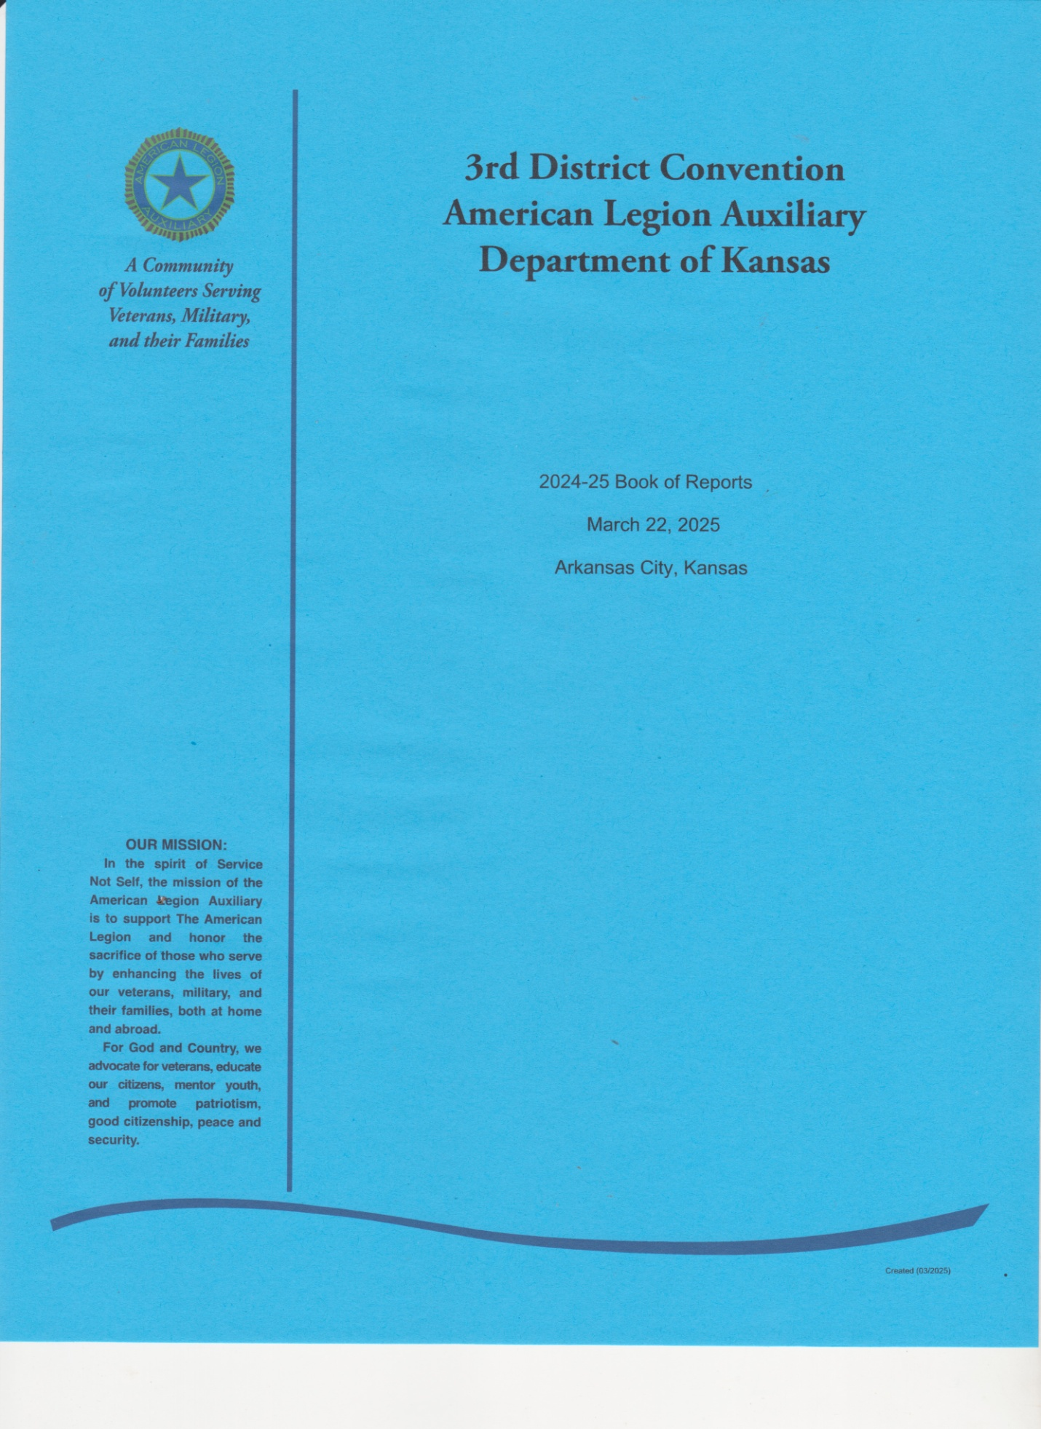

**PREAMBLE**

For God and Country,

we associate ourselves together for the following purposes:

To uphold and defend

the Constitution of the United States of America;

to maintain law and order; to foster and perpetuate a

one hundred percent Americanism;

to preserve the memories

and incidents of our associations in all wars;

to inculcate a sense of individual obligation

to the community, state, and nation;

to combat the autocracy of both the classes and the masses;

to make right the master of might;

to promote peace and goodwill on Earth;

to safeguard and transmit to posterity,

the principles of justice, freedom, and democracy;

to participate in and contribute to the accomplishment

of the aims and purposes of The American Legion;

to consecrate and sanctify our association

by our devotion to mutual helpfulness.

DISTRICT THREE OFFICERS

DEPARTMENT OF KANSAS

|  |  |
| --- | --- |
| President | Debra Carr |
| Vice President | Sue Coester |
| Secretary-Treasurer | Pam King |
| Chaplain | Paula Foelker |
| Historian | LaVeta Darbro |
| Sgt. At Arms | Dawn Martinez |
| Parliamentarian | Claudia Satterlee |

DEPARTMENT OF KANSAS

OFFICERS AND APPOINTMENTS

|  |  |
| --- | --- |
| Alternate National Executive Comm. | Cheryl Eastep |
| Secretary-Treasurer | Sue Coester |
| Historian | Laurie Kerns |
| ALA Sunflower Girls State Liaison | Pam King |
| Education & Scholarship Chairman | Debra Carr |
| Renew Crew Chairman | Debra Carr |
| Cadet Law Liaison Chair | Laurie Kerns |
| Community Service | Dorothy Wahl |
| Strategic Planning | La Veta Darbro |
| National Security | Cheryl Eastep |
| Poppy Chairman | Pam King |
| VAVS Representative to the  Kansas Veterans Home | Sue Boyd |
| Deputy Representative | Pam King |
| Deputy Representative | Claudia Satterlee |

DISTRICT THREE

COMMITTEE CHAIRS

DEPARTMENT OF KANSAS 2023-2024

Advisory Cheryl Eastep

Audit/Finance Laurie Kerns

Americanism Laura (Roberts) Culbertson

Auxiliary Emergency Fund Nancy Harris

Bowling Debbie Carr

Cadet Law Laurie Kerns

Cavalcade of Memories La Veta Darbro

Children & Youth Lora Banning

Community Service Lora Banning

Constitution & Bylaws Claudia Satterlee

Education & Scholarship Sara Evans

Eisenhower Pilgrimage Debra Carr

Sunflower Girls State Pam King

Junior Activities Tammy Dawe

Leadership Claudia Satterlee

Legislative Sharon Falkin

National Security Dorothy Wahl

Oratorical Windy Adams

Past President’s Parley Lee Ann Gingery

Poppy Windy Adams

Public Relations Linda Johnsrud

Veterans Affairs & Rehabilitation La Veta Darbro

Kansas Veterans Home

VAVS Representative Sue Boyd

Deputy Representative Pam King

Deputy Representative Claudia Satterlee

**District 3 Past Presidents**

1923-1924 Mrs. Amelaide Shephard

1924-1925 Mrs. Alice Shide

1925-1926 Mrs. C.D. Blackwood

1926-1927 Mrs. Nellie Cook

1927-1928 Mrs. Charles Rice

1928-1929 Mrs. Charles Morrow

1929-1930 Mrs. E.W. Griste

1930-1931 Mrs. Grace Davis

1931-1932 Mrs. Goldie Kelly

1932-1933 Mrs. Verne Fish

1933-1934 Mrs Helen McKinney

1934-1935 Mrs. Willard Morss

1935-1936 Mrs. Phaye Adams

1936-1937 Mrs. Fletah Sourdry

1937-1938 Mrs. Kathryn Allison

1938-1939 Mrs. Aubra Breene

1939-1940 Mrs. Kathryn Hite

1940-1941 Mrs. L.M. Athinson

1941-1942 Mrs. Tom Mallams

1942-1943 Mrs. Sue Conner

1943-1944 Mrs. J.H. Geier

1944-1945 Mrs. Gladys Britton

1945-1946 Mrs. Haxel Navarre

1946-1947 Mrs. Rex Garris

1947-1948 Mrs. A.K. Rader

1948-1949 Mrs. Ruby Schirmer

1949-1950 Mrs. John Hughes

1950-1951 Mrs. H.L. Cahoon

1951-1952 Mrs. Carl Telford

1952-1953 Mrs. J.N. Clifton

1953-1954 Mrs. Earl Wilkinson

1954-1955 Mrs. Louis Larson

1955-1956 Mrs. Very Boyce

1956-1957 Mrs. Tom Gilock

1957-1958 Mrs. Charles Harris

1958-1959 Mrs. Eugene Vance

1959-1960 Mrs. Marjorie Dunham

1960-1961 Mrs. John Chambers

1961-1962 Mrs. Don Cushman

1962-1963 Mrs. James Leyden

1963-1964 Mrs. Marjorie Gibbon

1964-1965 Mrs. Emmett Fultz

1965-1966 Mrs. Walter Wright

1966-1967 Beulah Shafer

1967-1968 Mrs. Charles Varsolona

1968-1969 Mrs. Gladys Hardwick

1969-1970 Mrs. Maurice Marion

1970-1971 Mrs. Kenneth Cummings

1971-1972 Mrs. Mabel King

1972-1973 Mrs. Shirley Paulson

1972-1973 Mrs. Walter Wright

1973-1974 Mrs. Rolla Holden

1974-1975 Mrs. Paul Poznich

1975-1976 Mrs. Bonnie Tharp

1976-1977 Mrs. Margaret Rausch

1977-1978 Mrs. Bibian Krout

1978-1979 Mrs. Charlotte (Rickets) Smith

1979-1980 Mrs. Dorothy Malone

1980-1981 Mrs. Maxine Earle

1981-1982 Mrs. Betty Carter

1982-1983 Mrs. Shirley Hartley

1983-1984 Sharyn Davis (inactive)

1984-1985 Mrs. Beverly Hunsaker

1985-1986 Mrs. Kay Pontious

1986-1987 Claudia Satterlee

1987-1988 Marjorie Osmundson

1988-1989 Leota Seefeldt

1989-1990 Janice Kitchen

1990-1991 Loydene West

1991-1992 Doris Ponds

1992-1993 Rosemary Bosetti

1993-1994 Pam King

1994-1995 Claudia Satterlee

1995-1996 Debra Carr

1996-1997 Kathy Moon

1997-1998 Phyllis Miller (inactive)

1998-1999 Georgella Caldwell

1999-2000 Laura Van Teighen

2000-2001 Afton Stark

2001-2002 Cookie McCoy (inactive)

2002-2003 Margaret Weston

2003-2004 Linda Schafer

2004-2005 Jan Wolfe

2005-2006 Janie Kennedy (inactive)

2006-2007 Mary Melvin*

2006-2007 Kay Pontious

2007-2008 Kay Pontious

2008-2009 Joanna Trenary (inactive)

2009-2010 Margaret Allen

2010-2011 Charlene Wilkinson

2011-2012 Donna Thomas (inactive)

2012-2014 Penny Vanderpool

2014-2015 Margaret Allen

2015-2017 Cathy Muller

2017-2019 Cheryl Eastep

2019-2021 LeeAnn Gingery

2021-2023 Dorothy Wahl

2023-2024 Debra Carr

= deceased *= passed mid-term

**DISTRICT PRESIDENT DEBBIE CARR**

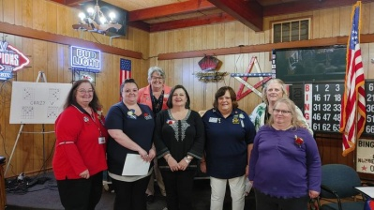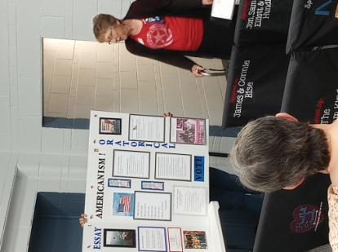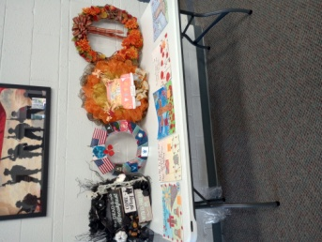On March 23, 2024 I was honored to have the District nominate me for another term as District President at our convention in Coffeyville. Vice President Sue Coester and I were elected and installed at Department Convention on June 2nd. Cherokee Unit35 was kind enough to invite for us to have our District Executive Board in June at their Post. The food was wonderful! The hospitality was wonderful. Leadership Chair Claudia Satterlee and I did some Leadership training while the District books were being audited. It was great to have members from several units that were not District officers or program chairmen attend, including the first time for a male ALA member to join us. He was impressed with the scholarship possibilities for his children as they get older.

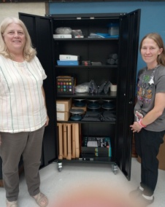My 2023-24 President’s Project was for art supplies for the Kansas Veterans Home in Winfield. The red, white, and blue bird bath raffle raised $2110 in donations.

September 22nd brought the Legion Family District Homecoming celebration with Dist. Commander Melvin Eubanks & Dist. SAL Commander Ronnie Rommel in Chanute’s Boerstler-May Post 170.

Dept Fall Conference was Oct. 5th at Post 408 in Derby. Wreaths were auctioned off to raise funds for Pres. Tracy’s President’s Project.

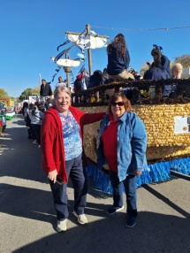The Newoellah parade in Independence was a lot of fun with Dist. VP Sue Coester and others who rode the float with us as we tossed candy and coozies to the hundreds of kids that lined the parade route.

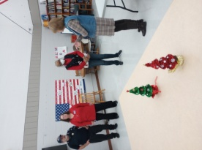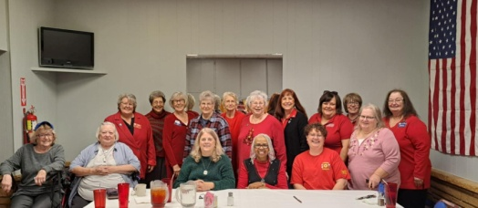In December, Dept. Pres. Tracy and I visited and helped with the KVH Gift Shop. I was able to stay an extra day and help wrap gifts. At the end of the week, KVH had another VIP visitor, Central Division National Vice President Rosemarie Hauk. Dept. Pres. Tracy, Dept. PDP Jeanne Haas, Dist. VA&R Chairman La Veta Darbro, VAVS Rep. to KVH Sue Boyd and I toured the facility with our special guest and accompanied her to a luncheon at Post 10. It was nice that we were able to introduce her to PDP 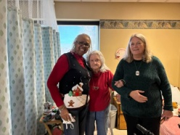Dorothy Malone, my mom and resident at KVH.

Although I couldn’t make it back to Winfield for 3 weekends in a row, I was able to participate in the Wreaths Across America ceremonies at Bartlesville’s oldest cemetery, the White Rose Cemetery. Some friends and I showed up at 8 a.m. to help unpack and prepare the wreaths for the service, then came back at 11 for it. One of the highlights of the ceremony was the Sons of the Revolution who very authentically couldn’t get all flintlocks to fire as planned.

Then it came time to place the wreaths and reflect on these men’s sacrifices. It was a very moving experience to lay a wreath at a 19 year old soldier’s grave who only made it from D-day to Christmas Eve that year. The very next grave was also a soldier from 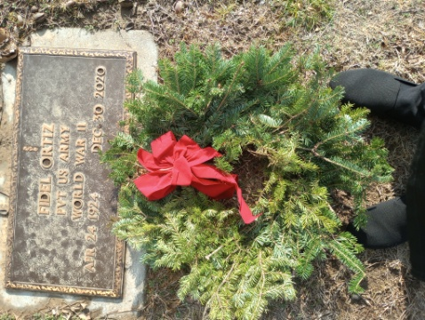WWII, however he lived to the age 96. 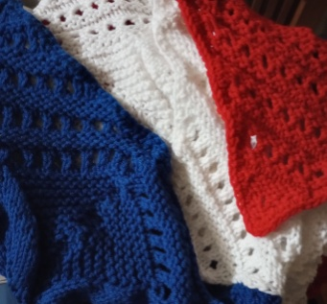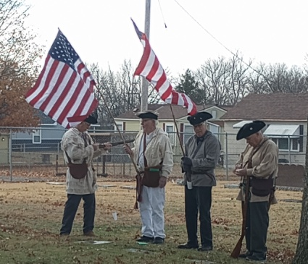

**DISTRICT VICE PRESIDENT SUE COESTER**

**DISTRICT CHAPLAIN PAULA FOELKER**

**THIRD DISTRICT HISTORIAN REPORT (Jan – Dec 2024) LA VETA DARBRO**

All sixteen Units (100%) in Third District reported the Historian, if they have one, worked 282 hours with the Secretary, Cavalcade of Memories chair, and members to preserve the activities & history of the Unit with photographs, documents, news articles, personal mementos, and prior histories & minutes. Added to the memories this year, Independence, Chanute, Alma &amp; Cherokee have added Facebook pages to alert members of activities & upcoming events, while documenting special occasions.

Independence reported a monthly newsletter starting December 2024. Due to changes in leadership, many Units report “learning” their roles and use minutes recorded & filed as tools to plan. Columbus, Pittsburg, Caney & Weir reported struggling for lack of meetings or rebuilding with few members to accept the duties of office, however, District President Debbie Carr has been helping revitalize them.

Winfield #10 won First Place at Convention 2024, with Independence #139 taking Second Place. I look forward to three or four histories to judge Thank you for all you do to archive and keep history alive in the American Legion Auxiliary. Third District will have a history to judge at Department Convention.

UNIT PRESIDENTS REPORTS

ARKANSAS CITY UNIT 18

ARMA Lon Helm, Jr. UNIT 182 Steffany Peternell, President

July through December

July – The Auxiliary had a rummage sale to help the Post. Auxiliary members donated 100 hours and raised $90 in this endeavor.

August – The Aux. helped with a Spaghetti feed during our Arma V.J. Homecoming. Also several of the ladies donated 8 cakes for a value of $40.

September – Auxiliary had a dinner and membership evening. Also played Bingo for several prizes

October – donated candy for the annual Trunk or Treat which is held at our High School parking lot – also Legion members assisted and donated candy as well.

November – Nov. 11 we had our Veterans Day Program and we served dinner to veterans at the Post. It went over well. Everyone really enjoyed the food. Also in Nov. we were honored to have the National Vice Commander for dinner. This was for members and guests. This was a great night for all of us. Very glad to have officers. We had cake donations from our Auxiliary members.

December – 1) Auxiliary Christmas Party – dinner, Bingo and gifts for the members – a fun night

2) We donated $100.00 to the Community Christmas baskets – which the community has a Cantata and the public also donated money to help families. We were able to help 14 families this year.

3) $250.00 was donated this year for next year’s Wreaths Across America which will go to the National Cemetery in Ft. Scott, KS.

4) The Legion –SAL-Auxiliary donated $150.00 and went grocery shopping for the families in our School District 246 so they may go to our public library to the food pantry and get help with what they need.

BAXTER SPRINGS UNIT 206 SHARON DAY, PRESIDENT

There are about 10 active members in our unit. We have other members (7), of course, they are unable to attend either because of various health issues, or they have jobs. With that said, I feel our little group does a pretty good job of being a presence in our community. We hope to expand our efforts in 2025.

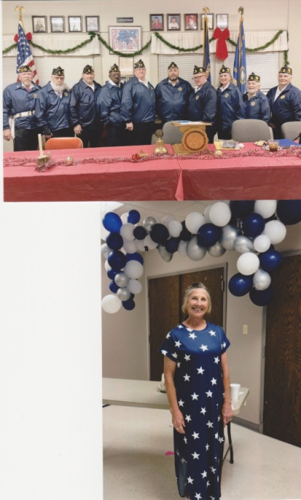We started off our yearly activities in May with a Ham & Bean feed. It was open to the community, and very well attended! We offered Ham & Beans, Corn bread, Fried potatoes, Dessert, and Drink for $7.

Every Memorial Day, our unit goes to the National Cemetery outside Baxter and displays 2 oversize wreaths to honor veterans. We include signage to inform those visiting the cemetery about them being supplied by our local Auxiliary.

We sent a $50 donation for the yearly poppy fund.

Baxter Springs hosted a special event surrounding July 4th festivities held in Kiwanis park. Our Auxiliary Unit decided to participate by putting up a canopy and offering free small flags and bottled water to anyone stopping by. We also had bagged homemade cookies that we sold for 50 cents/bag. It was well attended – we ran out of cookies.

In October, we hosted a 2nd community event. This time it was a chicken and noodle dinner. This was well received and provided funds to use towards other efforts we like to support for our local American Legion, as well as state events. We did so well that we ran out of food!

In the fall, our town has a fall decorations event. All the local businesses decorate their frontages, and then there is a contest to see which ones are the top 3. Our auxiliary ladies go all out to decorate the front of our Post, so it stands out as a participant in the town’s activities. The Post is on our main street. We didn’t win, but we were proud of our post, and left it up until after Thanksgiving.

We donated to the Freedom Riders Motorcycle Club. Baxter has quite a large group of riders, and we wanted to show our appreciation to them as they ride in our local parades, etc.

When the fall decorations come down, our auxiliary decorates Post 206 for Christmas and we leave it up through the New Year. This includes a huge Christmas tree as well as other decorations inside and out.

We sent $500 to the Winfield Veterans home for Christmas to help support their Veterans Holiday Gift Shop. The American Legion added $300 to our gift, so we sent $800 altogether.

As our American Legion members meet every month, we are involved in a couple of ways. Each month, (except 5 months of the year) at their meetings, a meal is served. Sharon Day cooks these meals, and the adjutant Jim Day serves them for a minimal charge to cover the food supplies. The other 5 months are potluck meals where the members are encouraged to invite their wives and bring a covered dish. The Auxiliary always decorates the tables and goes the extra mile to make these evenings special. These are a huge draw, and very well attended. Our primary function is to be a supportive presence for our American Legion members. They know we’re behind them, ready to help in any way.

CANEY UNIT 138 Debbie Moore, President

Debbie became Unit President late in the year and has done a stellar job. Under her leadership, the Unit has started having meetings again, visited KVH, become more active in the community, and with supporting the local Post. The unit has surpassed goal by about 50% with several new members. (I neglected to tell her about this duty, so I thought I would brag on her. She’s earned it! Debbie Carr)

CEDAR VALE UNIT 201 Marcia Magnus, Unit 201 President

Each Memorial Day, the Kemper Barnes American Legion Unit holds a Memorial Day Ceremony at the Cedar Vale Cemetery honoring our local Veterans. Several of the Kemper Barnes American Legion Auxiliary Unit #201 members help the American Legion Post with putting out flags at Veteran graves at the area cemeteries on Memorial Day weekend as well.

Cordelia Clapp, who is a Senior member of Kemper Barnes American Legion Auxiliary Unit #201, along with one of her granddaughters and great-granddaughters dress in full native regalia, and do interpretive American Indian Sign Language to The Star-Spangled Banner, God Bless American, and The Lord’s Prayer. They have performed at many events in the area, and a few of these events are listed below.

The Four Chaplains Memorial Service was held by The American Legion Department of Kansas on February 4, 2024 at the Mid-Winter Forum at Lysle Rishel Post #68 in Hutchinson, Kansas. The program was closed doing the interpretive American Indian Sign Language to God Bless America and The Lord’s Prayer, then followed by TAPS. Mrs. Clapp stated that this program will always hold a special place in her heart, as to be in the presence of the God Star families was such an honor, and then they gave her, her granddaughter and great-granddaughter a standing ovation with tears in their eyes; they were so appreciative of our presentation. There were approximately 200 in attendance at this event.

Cordelia also states that they participate in the Cedar Vale, Kansas Labor Day parade each year in September, as well as the Ponca City, Oklahoma Veterans Day parade, which is held on the second Saturday in November each year. They start the parades by doing interpretive American Indian Sign Language of The Star-Spangled Banner, as well as God Bless American and The Lord’s Prayer. For the Veterans Day event in Ponca City, there is a luncheon held in the park with approximately 300 veterans and their families in attendance.

CHANUTE UNIT 170

CHEROKEE UNIT 35

**Priestly-Ridley Unit #35 Auxiliary – Cherokee, KS**

**Impact Report/Narrative – President Autumn Martinez**

Cherokee Unit #35 promoted ***Americanism*** with 5 members collectively spending 30 hours preparing flags, placing flags on graves, folding and unfolding flags for the Avenue of Flags, and removing flags before/after Memorial Day. We also donated a new flag to our local Fire Department to replace the worn/tattered flag they had. We helped set the stage for the singing of our National Anthem at Cherokee’s Fall Festival.

With assistance from our Post ***Chaplain***, as we do not have one of our own, we draped our charter following the passing of one of our members, Cathy Norris, and held a prayer for her and her loved ones at our meeting following her passing.

***Membership*** for our unit currently sits at 39 paid members (91%) of our paid goal of 43. Our members carry at least one application with them for times when they may come across someone whom they find interested in joining the ALA. Our Unit President is quick to input memberships into ALAMIS, and forward the necessary paperwork onto Department. Since June, we have signed 3 new Junior members, and 9 new senior members.

For ***Education and Scholarship***, Unit #35 presented a $350 scholarship on American Legion Family Day, last April. We were active in the Give 10 to Education, buying 220 items such as loose paper, notebooks, folders, 3-ring binders, pencils, erasers, highlighters, crayons, colored pencils, and glue sticks. We also purchased a roll of American Flag Stickers, and affixed one sticker on each folder, 3-ring binder, and notebook. Our Unit President volunteered 3 hours to sit at the local school enrollment to hand out the school supplies. 6 total volunteer hours, and approximately $528 were spent for this program.

***Children & Youth*** keeps us busy year round! Unit #35 organized our local Easter Egg hunt, with around 30 children attending. We collected a donation of 10 pizzas from Domino’s, 5 dessert pizzas from Mazzio’s, and free Frosty coupons from Wendy’s. 6 ALA members participated, spending $120, and working collectively 12 hours to make it a success! We helped set up games for kids at our American Legion Family Day, as well as preparing and serving hamburgers to everyone attending. For Halloween our Unit partnered with our SAL brothers for a Children & Youth Pumpkin Decorating Contest. 5 ALA members volunteered 10 collective hours for this event, serving 14 children. 12 ALA members assisted in organizing and participating in a benefit ride for a local child who was diagnosed with Ewing Sarcoma. We helped raise over $2000 to assist her family with medical expenses. For Christmas, our American Legion Family “adopted” 7 children in Foster Care, purchasing gifts from each of their wish lists, as well as assisting in coordinating our annual Christmas with Santa. 9 members volunteered a collective of 24 hours to shop, wrap, and deliver gifts. A total of $560 was spent on Christmas gifts and events. Several members also spent time over the summer and fall attending Little League, football, and basketball games supporting youth in our community.

For the ***Veterans Affairs & Rehabilitation*** program, Unit #35 had 7 members participate in a Quilt of Valor Service for 2 Veterans at our Post home on November 10th. 3 members volunteered to prepare and serve dinner to 11 Veterans on Veteran’s Day. 6 members collectively volunteered 15 hours for Wreaths Across America Day at historical Oakwood Cemetery in Parsons, helping lay around 300 wreaths. In coordination with our Post family, we assisted in purchasing gifts for 20 Veterans for Christmas together spending $258. For this, 2 ALA members volunteered 2 hours purchasing and wrapping the gifts. December 23rd, 2 members of our ALA unit partnered with 2 members of Pittsburg Post 64 (dressed as Santa & Mrs. Claus) to deliver the gifts to the veterans in person at the nursing home, spending around 3 hours each. This truly warmed my heart so much, seeing the smile on each of the Veterans’ faces. We had 5 members volunteer their time to take a veteran to doctors appointments, take them grocery shopping, or simply spend a couple hours visiting and playing board/card games with them.

For ***Poppy*** Day, Unit #35 set up a booth at Katy Days in Parsons handing out Poppy’s and Poppy stickers. 5 members attended and each spent the day with around 8 hours each of volunteer time. We raised $27.42 in donations.

Unit #35 is proud of our ***Leadership***! We have 2 members serving 3rd District ALA. Autumn Martinez, our Unit President, is 3rd District ALA Sgt-At-Arms for 2 years now, and Tammy Dawe, our Unit Vice President is currently serving at 3rd District ALA Junior Activities Chairperson. We had 3 members attend 3rd District Convention March of 2024. In June, our Unit hosted 3rd District ALA post-Department meeting at our post home with 5 members of our Unit present. Our SAL coordinated with us to make lunch for everyone attending the meeting. Our Unit President and Unit Vice President attended 3rd District Homecoming, and our Unit President participated in 2 monthly Grassroots calls with Dept. President Tracy and other units across the state.

Our Unit is new to having ***Junior*** members but blessed to have 5 of them! We had 2 junior members assist with hiding the over 300 eggs during our Easter Egg Hunt for the community. 2 Juniors assisted for Memorial Day with placing flags and collecting and folding flags afterwards. We had 2 of our Juniors spend around 9 hours through the summer cleaning yards for Veteran’s. 1 junior member helped serve and clean up food during our Fall Festival, and 3 juniors assisted our American Legion Riders with their bike show for Fall Festival as well. 2 juniors helped with our Christmas with Santa gift handout.

For ***Public Relations***, our Unit President helps run our shared Facebook page to publicize events and keep all of our Post/Unit/Squadron members updated and engaged. Our unit Historian had an article written in The Pittsburg Sun, and time on a local news channel about our American Legion Post 35 family wanting to help restore a very old monument at the Pittsburg Atkinson Airport, which is dedicated to Tommy Atkinson, who was known as “the Flying Legionnaire” from Pittsburg’s American Legion Post 64.

We have about 12 participating members out of the 39 members in our Unit. Some of our members live far away or are unable to attend meetings/events due to health reasons, but we are thankful for each and every membership. Our unit is involved in some way with every event that goes on at our Post home, as our unit President and her spouse volunteer all of their spare time to managing the Post Lounge and the Food Trailer located at the post.

COFFEYVILLE UNIT 20

COLUMBUS UNIT 3

ERIE UNIT 102

GIRARD UNIT 26

HOWARD UNIT 149

INDEPENDENCE UNIT 139

ALA Harold R Andrews Unit #139 – Independence KS – 3rd District

Impact Report / January to December 2024 Narrative / Lora Banning, President

**AMERICANISM**’s patriotism & citizenship was visibly shown by members wearing red shirts on Friday, flying flags daily, & wearing ALA branding while volunteering with projects. Twelve members reported 398+ service hours during Memorial Day & Veteran’s Day activities placing & collecting flags at the cemetery with the assistance of Scouts, cleaning & repairing flags, marching in parades with meals to follow, and working Election Boards with 12 members voting in the Primary & General Elections. $100 was donated to the Downtown Flag Fund, $100 to Avenue of Flags, and $815 was spent to order new cemetery flags & markers, and tubs to store them in. The old tubs will be used for unserviceable flags for proper disposal. A new wreath was made for ceremonies, and two flags were donated to businesses to replace their worn flag.

**AUXILIARY EMERGENCY FUND** assisted eight members volunteering 190 hours spending $5,222. Raffle items helped a 43-year old get her kidney transplant in KC; another member was gifted kitchen cabinets & flooring when her floor collapsed. A Remington Weekend allowed us to help a cancer patient, while the Unit wrapped their arms around a member who lost her husband. Durable medical equipment was loaned to a member with new knees; while another member received transportation assistance & a pamper basket during phlebotomy treatments at the cancer center. One member picked up a battery to enable a member to have transportation while husband was away. The Unit donated to a member whose breaker box caught fire and helped with a live & silent auction for member having his kidney removed. Meeting dollars are placed in an AEF scholarship fund to assist payment of Unit member’s dues that may need help. Assisting members as drivers for doctor/hospital appointments, laundry & providing meals kept local members busy.

**CAVALCADE OF MEMORIES/HISTORIAN** work together to preserve the activities and history of Unit #139 with photographs, documents, news articles, personal mementos, and prior Unit Histories. Added to the collection this year are a Facebook page for members and a monthly newsletter. Brea’s Unit History placed 2nd at 3rd District Convention in March.

**CHAPLAIN** reported 10 Senior Members served 108 Hours/ 2,000 Miles/ $830 Money - gas/food donated. 329+ Cards Sent: 34 Get Well / 18 Recovery Sympathy / Lots Everyday Online for Condolences &Birthday / 7+ Lots Everyday Online for Well Wishes Thinking of You – Miss you. Other Cards explanation: 150 cards - Valentines, Veteran’s Day, & Christmas at Post. 75 cards were taken to 8 local nursing homes & KVH.

Chaplain Duties: 25 Hospital Visits / 8 Prayers before meals / 12 Prayers before Meeting / 20 Benedictions / 10 Member encouragement / 7 Funeral Service Assistance. 0 - Draping of Charter Members who have passed away between Jan 1 – Dec 31: Norma Foster (40 yr PUFL) 1-10-25. Assisted Bereavement/Celebration of Life Dinner: Doug Boomis; 3 veterans in June; Danny Blevins; Phil Hindle; Norma Foster (member). Chaplain Prayer book to be submitted at District Convention? Yes, working on it. Last year’s prayer book received First Place.

**CHILDREN & YOUTH** activities clocked 196 volunteer hours with $1,870 spent serving 30+ military kids and 3,449 non-military kids for supplies, gifts & prizes, candy & food, or coupons. Pop tabs were collected for Ronald McDonald house in Wichita and six backpacks were donated to the schools. Parties were held for 20 Quest Kids at Four County, Trunk-or-Treat, and Christmas food, fun & fellowship with 30 family children and 6 lucky bike winners. The Unit sent $50 for Operation North Pole that served 245 kids. The Unit was gifted 3 boxes of toys from Dollar Tree. We worked with the school for Girls State & Cadet Law. Lora serves as 3rd District C&Y chair and Windy serves as Oratorical chair. 3 members help with school activities. Ten members wore purple – Purple Up! For Military Kids April 15.

**COMMUNITY SERVICE** projects totaled 1,793 volunteer hours with $1,977 spent benefiting 60 veterans, 300+ military children, & 3,179 children in the community. Food, candy & desserts were donated for auctions, fundraisers, Thanksgiving & Christmas free community meals, meals following parades & Toy/Fun Runs, Food Pantries, & shut-ins. Adoption bag contents (blanket, leash, toy, food, etc.) donated to AWOL shelter for Pets4Vets. Earth Day helped plant flowers at Memorial Hall & downtown for Love Independence Day in April. 3 members took part in Memorial Day & Veteran’s Day ceremonies & 7 rode/drove float for Neewollah, Thanksgiving & Christmas parades with district & department dignitaries. 3 helped during HOP (Health on Purpose) Wellness Fair in September & 3 assisted US Cellular Honors Veterans & their families in November. Donations were given for the community fundraiser to help an ATV accident victim, the annual Independence Family Play Day/Yard Games/Fireworks, & lots of candy passed out to 1,000+ Trunk-or-Treaters. Proud to have our own Lora serving as 3rd District Community Service CH.

**CONSTITUTION & BYLAWS** are continually reviewed for accuracy & compliance with district, department & national, with members exercising their vote at all levels. Unit #139 is presenting a proposal for consideration. Article III Eligibility Section 1. As eligibility for membership in the American Legion Auxiliary is determined by the American Legion governing documents as printed… we propose to add:

1) Grandfathers, fathers, brothers, sons & grandsons to the current reading, as persons being related by the same level of consanguinity to a veteran.

Section 2. No change, as there is no reference to gender, so automatically includes those newly eligibility.

**EDUCATION / SCHOLARSHIP** – Unit #139 provided 2 - $500 Duane Ham Memorial scholarships in April, asking entrants to “Pick a First Lady who you think was instrumental in promoting the Military & Veterans”. $250 was added to the #139 Family Legacy Run donation of $1,750 during the Independence stop. 5th Week Fundraisers are scholarship fund specific- game day snacks & giveaways & family style meatloaf. $50 in supplies donated to Head Start and 6 filled backpacks ($300) were given to elementary schools for “Give 10 to Education”. Donna worked with the HS counselor to purge old forms & information & made certain current scholarship, Girls State, & Cadet Law is available. Volunteers served 132 hours spending $1,880 benefiting 314 children. 2025 Theme: American Veterans Mental Health – Is it being properly addressed?

**EISENHOWER PILGRIMAGE** rose was purchased by the Unit and 3 members attended the Pilgrimage in Abilene in October. Additionally, 2 members were honored to stand vigil for 2 hours at the Chapel Place of Meditation.

**SUNFLOWER GIRLS STATE** information was distributed to the HS, however, after following up, no delegates.

**JUNIOR ACTIVITIES** consisted of helping distribute poppies, placing flags on veteran graves, & setup & cleanup for meals & projects. Two juniors and local scouts added approximately 200 hours for the program.

**LEADERSHIP** for Unit #139 begins with mentoring & being informed. National’s Program Book, the Unit Guide Book, and resources on the web assist leaders & chairs to carry out projects. Streamlined roll sheet assists with on time report accounting, volunteer hours & evaluation. In March a full slate of officers & chairs were filled, with leadership pins replaced. Lora, Windy & LaVeta accepted chairs for 3rd District and attend district & department functions & ZOOM calls. #139 officers ensure timely filing of 990-N, perform internal quarterly audits, & handle complaints &/or compliance issues. Following Department President Tracy’s theme: “Ride the Tide for Veterans, Make Each Wave Count” we’ve been host to National Vice Commander James Kellogg, been honored to welcome Central Division National Vice President Rosemarie W Hauck, & supported National President Trish & the ALA Foundation by purchasing & using the ALA Challenge Deck for our Unit. Officers & chairs reported 186 hours volunteered, $105 spent, not counting gas for 1,760 miles traveled to Coffeyville, Topeka, Indy, Cherokee, Emporia, Chanute, Wichita, Derby, & Winfield.

**LEGISLATIVE** efforts included 3 members that attended First Friday Shoutouts to promote ALA awareness & have proclamation signed for Poppy Day. Two members worked the Primary Election & the Presidential Election with 12 members reporting they voted. Windy & LaVeta attended the Veterans Strategy Summit at the Capitol in September discussing priority goals with legislators & Representatives Chris Croft & Doug Blex and former AG Derrick Schmidt. Three members worked 87 hours and clocked 560 miles working legislative issues for veterans & their families. Unit members follow the national legislative group Facebook page & local legislators for updates & objectives.

**MEMBERSHIP** in Independence #139 is a team effort led by Donna, with Andrea & LaVeta providing technical support on ALAMIS. We finished the 23-24 year with 77 of Goal 80. Following Department Vice President Kristen’s Theme: Setting the Course – Goal 80, Andrea designed informational posters to attract new members & family application brochures are located behind the bar for easy access. ALAMIS is utilized almost daily for approximately 300+ hours. A membership scholarship fund from meeting dollars can be used to assist members who may need help.

**NATIONAL SECURITY** projects facilitated by our Rider members – Welcome Homes, Send-offs, funeral escorts & celebrations of life, hours are not recorded. However, 5 dual members assisted in this report. 12 members clocked 24 hours collecting donations for 1st BN 635 AR with two boxes & $500 in July. In November, 2 boxes sanitizer & 2 boxes Rice Krispie treats ($150) were sent overseas. The Unit sent $50 to help with the Big Red One Turkey Run at Ft Riley providing food for 600 families; 300 - $30 gift cards to the Commissary for the Soldiers Recovery Unit; with 40-50 volunteers. We also support the Veteran Banners Downtown on light poles Memorial & Veterans Day.

**POPPY** Day distribution was held by proclamation May 24 with Kristin, Andrea, Jan, & Lora manning the drive-thru at the park. Poppy bookmarks were ordered ($59) & 1,000 poppies; cans were placed in businesses: Antlers, Sassy’s, Bacon’s Coffee, Stoney’s, Community National, Uncle Jacks, & Equity Bank. 5 volunteers served 29 hours. Windy serves as 3rd District CH.

**PUBLIC RELATIONS** American Legion Auxiliary Unit 139 Facebook group page publicizes activities, a calendar of dates & upcoming events to keep members informed. Minutes are published monthly in *The Independence Reporter*  & placed in a notebook at the Post. Brea is the editor of our new Unit Newsletter published monthly & available to all members. The resources provided by department & national websites, as well as the *Sunflowerette* provide much needed guidance. Calling Tree CH Cassie follows meeting policy: No School/City Closures – NO Meeting. Promoted “Be The One”, TAL & ALA Birthdays, & Rosie the Riveter Day, among other military observances. Andrea made new posters to promote the ALA & membership. Attached magnets to 20 patches so members could be in uniform. Purchased an updated ALA Unit Banner & an all-weather banner for parades. 5 officers worked as a publicity team for 114 hours spending $250.

**STRATEGIC PLANNING** is a team effort that includes priorities, goals, objectives, & obstacles for membership – research, revitalizing, recruiting & retaining. Our team is part of the department team of district chairs, Claudia Satterlee, Jesse Mueller, & me. The Strategic Plan includes Membership – Renew, Retain, Recruit, Revitalize = Growth & Success; Improve Visibility – Dream & Do; Enhance & Highlight Vision & Mission; Leadership Responsibilities Defined; and CIP – Communication Improvement Plan. We meet quarterly & have posted information on department’s website that include Strategic Planning Information; Congratulations You’re a New Unit/District Officer &/or Committee Chair; ALA Healthy All Star Unit Check Sheet; Monthly Obligations & Military Observances; and (pending) Healthy All Star Unit Certificate.

**TECHNOLOGY** is still a major obstacle for some members, so we back up with calls & paperwork to include all.

**VA&R** is an every day goal. 35 members reported 1,814 hours, donated $6,281 in service to veterans and 1,191 hours, $3,985 in service to military families. $50 was donated to Winfield for Gift Shop. An Eisenhower Pilgrimage rose was purchased. $100 each was donated for Veterans Freedom Square Memorial in Independence Riverside Park and the Avenue of Flags. $105 was donated to AWOL Pets4Vets free adoption for veterans & packed bags & supplies for adoption kits. Valentines were made & placed at the Post & delivered to homebound. Lora & family donated $3,500 value durable medical supplies & new clothing to KVH. The Unit gave the Post $100 for their March 15 birthday. 6 Rider members took part in May’s Run For the Wall. The ALA Foundation Cards for Veteran Project Fund were donated to the Unit. Throughout the year, Buddy Checks, personal care, transportation, shopping, laundry & assistance were provided by 12 members for another 180 hours of service to veterans. Member LaVeta serves as 3rd District CH.

PITTSBURG UNIT 394

WEIR UNIT 272

WINFIELD UNIT 10

DISTRICT COMMITTEE REPORTS

**AMERICANISM**  **LAURA (ROBERTS) CULBERTSON, CHAIRMAN**

Units: 16 Units Reporting: 6

Hours: 628 Money spent: $1905

Miles driven: 576 Veterans Served: 2000

Active Duty served: 10 Public served: 600

Francis Roland Romack Unit 206 in Chanute reported working 108 hours, spent $720, drove 300 miles, and helped 1800 veterans working the Americanism program in 2024. The Auxiliary Unit assisted the Post 20 honor guard, helping with over 20 funerals.

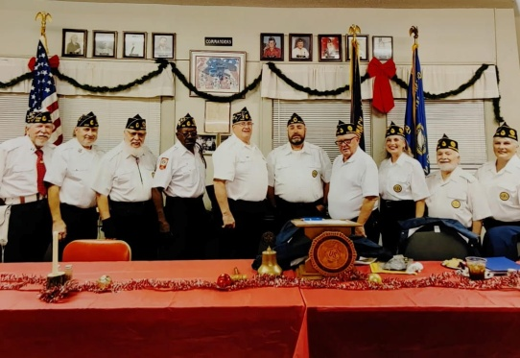

Winfield Unit 10 reported working 43 hours, spending $170, helping 50 veterans and 10 active duty military and drove 76 miles. One member received special honors for attending community parades representing Post 10 as an Auxiliary member in the Honor Guard. Severn members folded 200 flags placed in Winfield cemeteries during Memorial Day weekend. 11 members attended Wreaths Across America at Kansas Veterans Cemetery in Winfield. Members also distributed the wreaths on the graves. Unit 10 purchased 10 wreaths at $17 each. The Unit purchased and framed a new Preamble for Auxiliary meetings. Chair Stacee Woody encouraged everyone to vote and watch the inauguration. Galle reported attending a speech presented by Dwight D. Eisenhower’s great-grandson Alex Eisenhower. Members regularly attend Bingo for KVH residents.

Priestly-Ridley Unit 35 in Cherokee reports working 30 hours working the Americanism program. 5 ALA members collectively spend 30 hour preparing flags, placing flags on graves, folding and unfolding flags for The Avenue of Flags, and removing flags after Memorial Day. They donated a new flag to our local Fire Department to replace the worn and tattered flag they had. They also helped set the stage for the singing of the Star Spangled Banner at Cherokee’s Fall Festival.

Harold R. Andrews Unit 139 of Independence reports working 398 hours and spent $815 in working the program. AMERICANISM’s patriotism and citizenship was visibly shown by members wearing red shirts on Friday, flying flags daily, and wearing ALA branding while volunteering with projects. Twelve members reported 398+service hours during Memorial Day and Veterans Day activities, placing and collecting flags at the cemetery with the assistance of Scouts, cleaning and repairing flags, marching in parades with meals to follow, and working Election Boards with 12 members voting in the Primary and General Elections. $100 was donated to the Downtown Flag Fund, $100 to the Avenue of Flags, and $815 was spent to order new cemetery flags and markers, and tubs to store them in. The old tubs will be used for unserviceable flags for proper disposal. A new wreath was made for ceremonies, and two flags were donated to business to replace their worn flag.

Borstler May Unit 170 in Chanute reports working 40 hour and driving 200 miles while working the Americanism program. Unit 170 supported Americanism by members wearing red shirts on Friday, wearing A LA branding when sponsoring or attending community /post events and flying the flag at their residences.

Our members were essential to Memorial Day program/display/replace/remove flags from the cemetery and educating several community members on flag etiquette for graveside display. Members participated in flag line at Veterans Day Services at Royster Middle School, funerals, military honor nights, 9-11services, and participated in 8 parades with flags mounted/ displayed. Many of our activities were not accurately documented over the past year, but our members support Americanism programs each day.

Kemper Barnes 201 in Cedar Vale

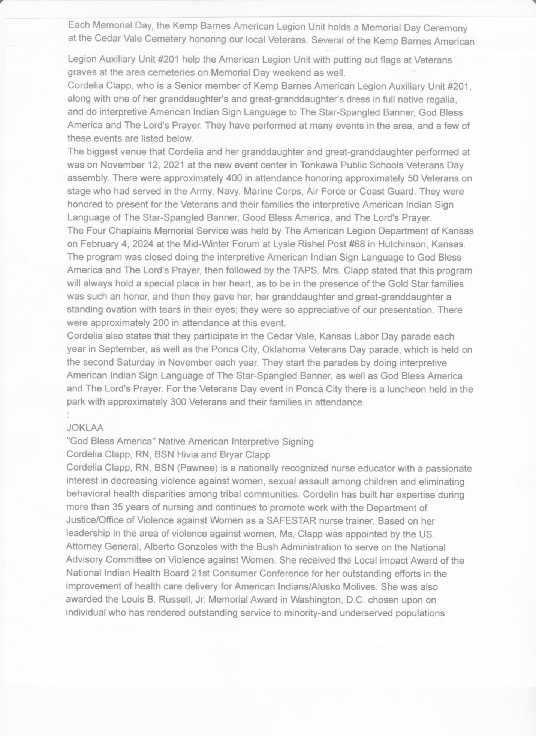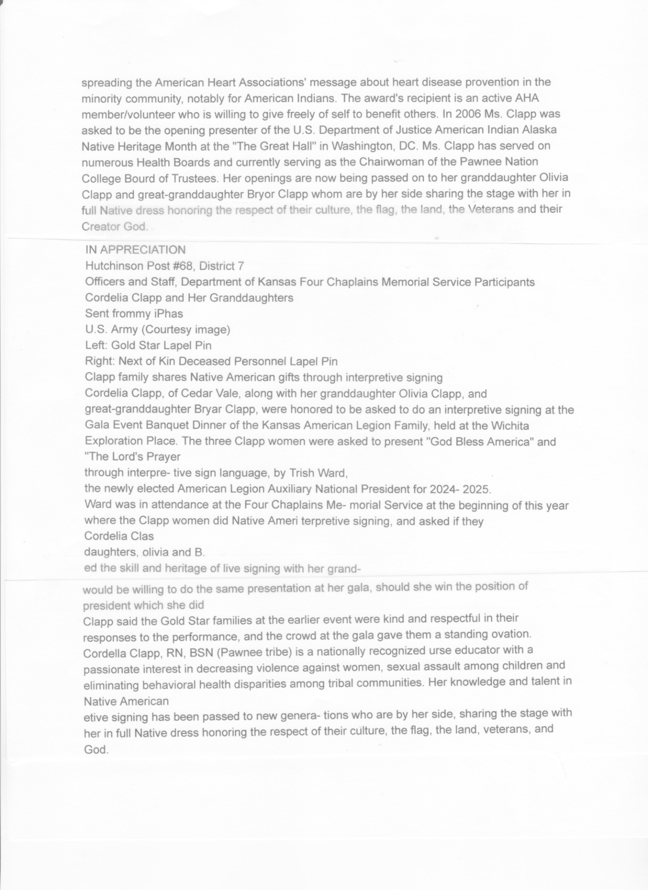

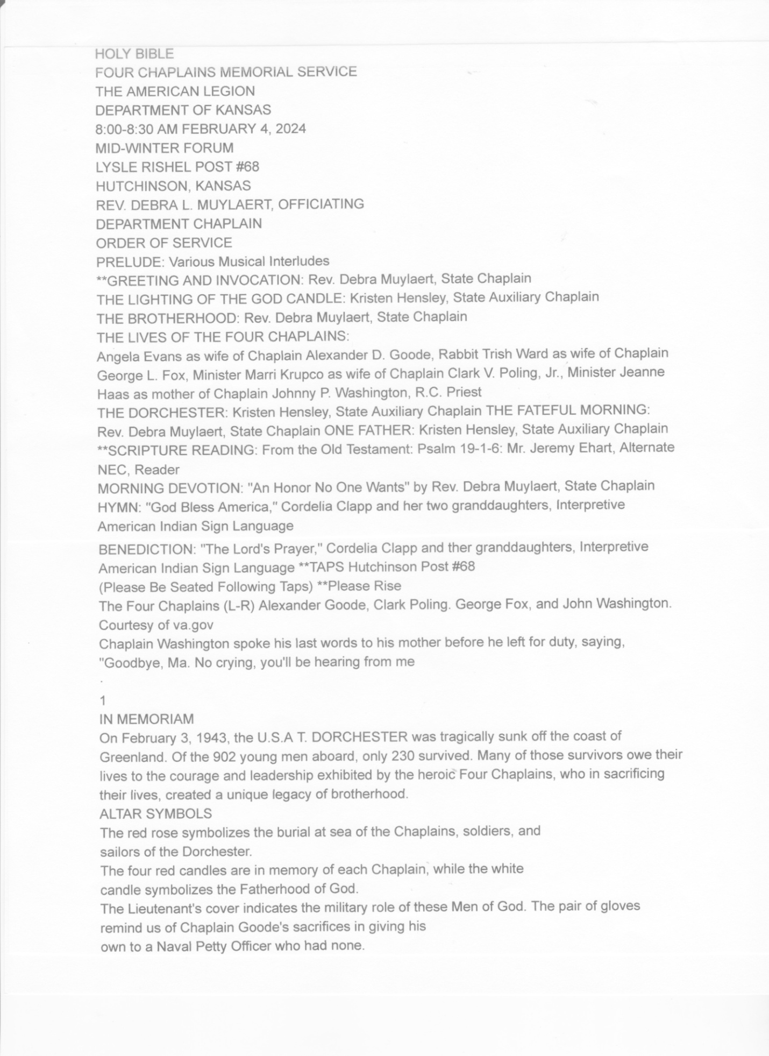**AUXILIARY EMERGENCY FUND NANCY HARRIS**

**CAVALCADE OF MEMORIES REPORT (Jan – Dec 2024) LA VETA DARBRO, CHAIRMAN**

All sixteen Units (100%) in Third District reported the Cavalcade of Memories chairman, if they have one, worked 242 hours with the Historian and Secretary to preserve the activities & history of the Unit with photographs, documents, news articles, personal mementos, and prior histories & minutes. Added to the collection this year, Independence, Chanute, Alma & Cherokee have added Facebook pages to alert members of activities & upcoming events. Independence reported a monthly newsletter starting December 2024. Due to changes in leadership, many Units report “learning” their roles and use minutes recorded & filed as tools to plan. Columbus, Pittsburg, Caney & Weir reported struggling or rebuilding with few members to accept the duties of office, however, District President Debbie Carr has been helping revitalize them. Thank you for allowing me to serve as your chairman.

**THIRD DISTRICT CHILDREN & YOUTH REPORT (Jan – Dec 2024) LORA BANNING, CHAIRMAN**

All sixteen Units (100%) of Third District reported 1,020 hours volunteered with $8,038 spent serving 230 military and 5,859 non-military children collaboratively with The American Legion to direct & sponsor programs & services for our nation’s children. Members worked Valentine’s Day, Easter, Purple Up for Military Kids (April 15), Earth Day, After Proms, Girls State, Trunk-or-Treats, Operation North Pole, Christmas, Volunteer at School Activities, while youth help with Memorial Day, Flag Day, Independence Day, Labor Day, Veterans Day, Thanksgiving & Christmas celebrations. Unit members supplied gifts, prizes, candy, food & coupons throughout the year for these activities.

**Arkansas City** used Indian Taco sales to purchase $10 gift cards for Christmas & pics with Santa for 250 kids. $250 donated to Cowley CC supported low income students or those with no lunch plan. $500 spent to provide 10 families turkey meals. $300 spent on Trunk-or-Treat donations for 600 kids. Due to covid helping Class of ’25 with $250. During Education Week took 800 color books to school. **Arma’s** Bingo/concessions funded their Easter Egg Hunt, $700 in scholarships (2 Legion/2 Aux), Christmas gift cards, & $150 toward school lunch balances/food pantry donations**. Cedar Vale** member Cordella Clapp, granddaughter, & great-granddaughter performed in full Native American regalia signing “The Star Spangled Banner”, “God Bless America” & “The Lord’s Prayer” Labor Day. **Chanute** reported a successful Trunk-or-Treat & adopting children from the Christmas Giving Tree. $400 was given to Girls State.

**Cherokee** was busy hiding 300 eggs for 30 kids with pizza donated by Dominos & Mazzios & frostys from Wendy’s. They partnered with the SAL for a Halloween Pumpkin Decorating contest with 5 members/14 kids. A benefit ride for a child with cancer raised $2,000. 7 foster children were adopted at Christmas, and members shopped, wrapped, & delivered gifts for Christmas with Santa. Members support youth sports & activities all year long. **Erie** promoted Girls & Boys State and Cadet Law at the local schools & sponsored one Cadet Law & one Boys State delegate. **Girard** donated $1,500 on Girls State & $250 for a local scholarship. **Independence** donated 6 filled backpacks to the school and adopted 20 Quest Kids at Four County for Easter. Dollar Tree donated 3 boxes toys, and #139 Legion Family gave away 6 bikes at Christmas. An 18-gallon tub of aluminum tabs was delivered to Wichita Ronald McDonald House. **Winfield** Unit has two members who organize the Cowley Kids Run, with Unit #10 donating $50 in Wal-Mart gift cards. $50 was donated to Afterglow, a party for graduating USD 465 seniors. Members donated food for weekend meals at the elementary schools. Several members & grandchildren participated during Poppy Day activities.

**ALA BOWLING COMMITTEE DEBBIE CARR, CHAIR**

One unit in the district, Boerstler-May Unit 170 in Chanute, reported that they participated in the State Bowling Tournament. Hours worked: 100 $ spent: $500 Mileage: 250 Their unit sponsored a bowling team of all current active Auxiliary members to attend and participate in the January American Legion Bowling Tournament held in Topeka.

**CADET LAW LIAISON LAURIE KERNS, CHAIRMAN**

**THIRD DISTRICT COMMUNITY SERVICE (Jan – Dec 2024) LORA BANNING, CHAIRMAN**

All sixteen Units (100%) of Third District reported 7,061 hours volunteered with $8,145 spent and 630 miles traveled helping 490 veterans, 55 active duty, 325 military kids and 3,484 non-military children served. By being visible the Community Service program demonstrates who we are, what we do, why we matter and to make our communities better places in which to live. Food, candy, desserts, & prizes for feeds, auctions & fundraisers; marching or riding in parades, Toy Runs, animal shelters, city-wide events, Memorial Day & Veteran’s Day activities, Angel Trees, Wellness Fairs, Trunk-or-Treats, food pantries, homeless shelters, blood donations, church leaders & assisting with Bingo were volunteered after saying “We don’t do a lot”.

Arkansas City reported every 3-6 months that $50 stuffed animals donated to local PD.

Arma has Spaghetti Feeds a couple times a year open to the public with members donating

cakes. Halloween showed $200 spent on candy (40 bags donated) for 200 kids. $150 donated

to grocery/food pantry at the library. $100 donated for community Christmas baskets for 14

families.

Cedar Vale’s Cordella Clapp, granddaughter, & great-granddaughter dressed in full

Native American regalia on several occasions signing “The Star Spangled Banner”, “God Bless

America” and the “Lord’s Prayer”. Chanute helped with Red Cross blood drive & donations and

hospital auxiliary assistance. They enjoy partnering both in the community & within their Post for

events held there. Cherokee has 7 members who help set up the stage for Cherokee’s Fall

Festival.

Erie members are always busy during the annual Bean Feed & Sailors and Soldiers Reunion Week parade & activities, partnering with their ALR.

Independence partnered with the VFW and community to help with both Thanksgiving & Christmas free meals. They hosted meals at the Post home following parades, Toy Runs, &

Memorial & Veteran’s Day ceremonies, with left-overs shared with food pantries, Community Access Center, & shut-ins. Volunteering & donations to AWOL adoption bags (blanket, leash, toy, food) & aluminum cans for Pets4Vets. Earth Day helped plant flowers at Memorial Hall &downtown for Love Independence. Members took part in Memorial Day & Veteran’s Day ceremonies at the park & Neewollah, Veteran’s Day, & Christmas parades with district & department guests. Had a booth at the HOP (Health on Purpose) Wellness Fair. Assisted US

Cellular Honors Veterans & their families with technology assistance. Donated to community fundraiser for a veteran ATV accident victim. Always a good time, Independence 139 annual Play Day/Yard Games/Fireworks in July had community & statewide participants. Trunk-or Treat had 1,000 children go through.

Winfield had 5 volunteers two days a week work the Canteen during lunch hour- open to the public. Two members organize & hold the monthly Bingo at the Post & collect prizes for winners. Two members volunteer weekly at Cowley Food Bank & commodity boxes. 20 members donated to the bake sale during the annual community bean feed. Several members volunteer at local churches & other charitable organizations.

**CONSTITUTION & BYLAWS CLAUDIA SATTERLEE, CHAIRMAN**

Units in District: 16 Units Reporting: 5

Two Units do not participate according to their report forms.

Unit 35 at Cherokee reviewed their constitution and bylaws and plan to revise the Unit C&B over the next few months.

Unit 139 at Independence reports they continually review their C&B for accuracy and compliance with District, Department and National with members exercising their vote at all levels. Unit #139 is presenting a proposal for consideration. Article III Eligibility Section 1. As eligibility for membership in the American Legion Auxiliary is determined by the American Legion governing documents as printed… we propose to add:

1) Grandfathers, fathers, brothers, sons & grandsons to the current reading, as persons being related by the same level of consanguinity to a veteran.

Section 2. No change, as there is no reference to gender, so automatically includes those newly eligibility.

**EDUCATION AND SCHOLARSHIP SARAH EVANS, CHAIRMAN**

Units in District: 16 Units Reporting: 5

Hours worked: 138 Dollars spent: $3,908

Number of non-military children helped: 314

Unit #35 presented a $350 scholarship on American Legion Family Day. We were active in the Give 10 to Education, buying 220 items such as loose paper, notebooks, folders, 3-ring binders, pencils, erasers, highlighters, crayons, colored pencils, glue sticks, and American Flag stickers that we placed on each folder and 3-ring binder. Our Unit president volunteered to sit at the local school enrollment to hand out the school supplies.

Unit #139 provided 2 - $500 Duane Ham Memorial scholarships in April, asking entrants to “Pick a First Lady who you think was instrumental in promoting the Military and Veterans”. $250 was added to the #139 Family Legacy Run donation of $1,750 during the Independence stop. 5th Week Fundraisers are scholarship fund specific – game day snacks and giveaways and family style meatloaf. $50 in supplies donated to Head Start and 6 filled backpacks ($300 value) were given to elementary schools for “Give 10 to Education”. Donna worked with the HS counselor to purge old forms and information & made certain current scholarship, Girls State, & Cadet Law are available. Volunteers served 132 hours spending $1880 benefiting 314 children. 2025 Theme: American Veterans Mental Health – Is it being properly addressed?

Unit #149 awarded 3 local $500 scholarships.

**EISENHOWER PILGRIMAGE DEBBIE CARR, CHAIRMAN**

Three units of the 16 units in District 3 reported participating in the Eisenhower Pilgrimage. Two made $10 donations for ceremonial roses and the District donated $15 for the District’s wreath for a total of $35. Miles: 466 One unit reported that they did not participate. Past Dept. Pres. and Alt. NEC Cheryl Eastep placed the wreath on behalf of the District.

**SUNFLOWER GIRLS STATE PAM KING, CHAIRMAN**

Eight of the sixteen units in District Three reported. Three of the units reporting did not participate in this program. One unit distributed the information about the 2024 Sunflower Girls State session but had no delegates attend. Howard was represented by 4 delegates, Chanute and Winfield each had one delegate, and Arma had 2 delegates attend.

Members reported giving 18 hours to promote the program and also reported spending $3,100. There were some delegates attending the session from schools within the boundaries of District Three that did not have an Auxiliary unit in their town. Units need to reach out to their area schools which could help this program grow again and provide positive public relations for our organization.

**DISTRICT #3 JUNIOR ACTIVITIES 2024 TAMMY DAWE, CHAIRMAN**

***Unit #170 Chanute***

Sponsored 1 girl to attend Girls State

**Hours Worked (10) Dollars Spent ($400) Non Military Children Helped (1)**

***Unit #139 Independence, Ks***

Junior activities consisted of helping distribute poppies, placing flags on veterans' graves,

setting up/cleaning up for meals and projects. Two junior and local scouts added approximately

**200 hours** for the program.

***Unit #149  Howard, Kansas***

4 junior members that are very active. 3 leave school to attend lunch meetings 3-4 times a year.

On Memorial weekend, they put up flags on Thursday, Friday and Monday as well as flag removal on Monday afternoon. Last year junior member Bella traveled with our unit and Post to participate in 7 public ceremonies at local cemeteries. They helped with Annual Howard Fall Fest by working the cake walk after participating in the parade on behalf of our unit.  Zoie Crupper is our leader of the JR members. She has organized a bingo fundraiser that raised $3000 and will continue to be a yearly event. Zoe has spent many hours preparing for Oratorical and won 3rd at state level. We expect her to do well again this year. She organized a fundraiser for our local Senior Center, including getting other juniors involved. I apologize for not including any amounts, number of hours or pictures. We are quite proud of our hardworking junior members and this report does not do them justice, but it's the best I can do.

***Unit #206 Baxter Springs***

Did not participate

***Unit #35 Cherokee, Kansas***

2 Juniors helped hide over 300 eggs for the community Easter Egg Hunt. (2 hrs) 2 juniors helped place and collect flags from the Avenue of Flags for Memorial Day (12 hrs). 2 juniors spent summer hours cleaning up local veterans' yards. (9hrs). 1 junior helped serve and clean up food during Cherokee Homecoming events (6hrs). 3 juniors assisted the American Legion Riders with a community bike show (3 hrs). 2 juniors helped set up and participated with Christmas Santa gift giving for kids in the area (2hrs).  **Total of 34 hours, 5 Veterans helped, 1 Active Duty helped and 7 non military children helped.**

**LEADERSHIP CLAUDIA SATTERLEE, CHAIRMAN**

Units reporting: 4

Hours worked: 150

Dollars spent: 275.00

Mileage: 248

Veterans helped: 10

Active duty helped: 10

Six members attended 3rd District Convention in March 2024. Five members serve in District Officer positions. Unit 35 hosed 3rd Dist. ALA post Department meeting in June and several members of units present. 3 members attended 3rd Dist.Homecoming in Chanute. 4 members participated in 2 separate monthly Grass roots video calls with Dept. President Tracy and other units across Kansas. Unit members participated in planning meeting for 3rd Dist. Convention in March.

**LEGISLATIVE SHARON FALKIN, CHAIRMAN**

Units in District: 16 Units Reporting: 5

Hours Worked: 95 Dollars Spent $ 0 Mileage: 560

Veterans Helped: 0 Active Duty helped: 0 Military kids: 0 Number of non-military Children helped: 0

One unit reporting a member attended the ribbon cutting of the Iola VA clinic.  Taking the opportunity to talk with State Legislators present about the Auxiliary and our presence in the communities we serve.

Another unit’s efforts included 3 members attending First Friday Shutouts to promote ALA awareness and having a proclamation signed for Poppy Day. Two members worked the Primary Election and Presidential Election with 12 of their members reporting they voted. 2 members attended the Veterans Strategy Summit at the Capitol in September discussing priority goals with legislators. Including Representative Chris Croft and Doug Blex and former AG Derrick Schmidt.  Three members worked 87 hours and clocked 560 miles working legislative issues for veterans and their families. Unit members follow the national legislative group Facebook page and local legislators for updates and objectives.

**THIRD DISTRICT ORATORICAL REPORT (Jan – Dec 2024) WINDY ADAMS, CHAIRMAN**

The Oratorical program is a program of The American Legion. Auxiliary Oratorical Liaisons help the Legion with its program and is an important part of the Auxiliary’s Americanism program.

*3rd District Oratorical Contest 2024

The American Legion 3rd District Constitutional Speech Contest was held Sat., Feb. 17 at the Cox Building in Howard. This American Legion Oratorical Contest exists to develop deeper knowledge and appreciation for the U.S. Constitution among high school students.

Young orators earn some of the most generous college scholarships available to high school students. Over $200,000 in scholarships will be awarded this year throughout the United States. Zoie Crupper from West Elk High School was the winner, and Joshua Ozburn from Pittsburg High School won second place, based on the scores from five judges.

Department (State) Commander Randy Frank from Hillsboro and 3rd District Adjutant Aemisegger and Bill Clark, both from Post #139 in Independence, participated in the judging along with Auxiliary members Marcia Taylor Trump, Kate Perkins, and Sarah Evans.

The Legion family would like to thank Debbie Zellner for her leadership in promoting the contest to students at West Elk High School. Zoie next participates in the Department (State) contest in Manhattan, Kansas March 16.—Zoie took 3rd Place at Department & won the Girls State Samsung Scholarship.

*3 rd District Oratorical Contest 2025

Feb. 23, Zoie Crupper & Desi Swepston competed in the District 3 American Legion Oratorical Competition hosted by Larry Smith & Carter Rader Post #149 in Howard. To qualify for district, each participant had to place 1st in their local competition. Crupper came out on top & will compete in the State of Kansas competition March 15 in Topeka.

The prepared oration must be on some aspect of the Constitution of the US with emphasis on the duties & obligations of a citizen to our government. It must be the original effort of the contestant & must not take up less than eight minutes or more than ten minutes for delivery from memory.

There is also an assigned topic to test the speaker’s knowledge of the subject, the extent of his or her research, & the ability to discuss the topic as related to the basic principles of government under the Constitution. The assigned topics must take no less than 3 minutes & must not exceed 5 minutes. The 2025 Assigned topics are: Amendment I; VII; XVII – Section 1, 2, & 3 and Amendment XXVI – Section 1 & 2.

Crupper is the daughter of Benjamin & Shilo Crupper of Howard and a senior at West Elk High School. Swepston is the daughter of Sara Swepston of Pittsburg and a junior at Pittsburg HS.

**THIRD DISTRICT POPPY REPORT (Jan – Dec 2024) WINDY ADAMS, CHAIRMAN**

All sixteen Units (100%) in Third District reported, however, since the # of poppies wasn’t on the narrative report, many forgot…so volunteers reported 565 hours volunteered $159+ spent on 2,500 poppies helping 100 veterans.

**Baxter Springs** doesn’t distribute poppies but made a $50 donation. **Cedar Vale** is hoping to start back Memorial Day 2025. **Chanute** handed out poppies at their Memorial Service and during/after the Veteran’s Day parade bringing in $387.19 in donations. They also handed out poppies & stickers from their booth during Katy Days in Parson with five members for 40 hours volunteered.

**Independence** poppy day distribution was held by proclamation May 24 with 4 members manning the drive-thru at the park. Poppy bookmarks & 1,000 poppies were passed out. Collection cans were placed at: Antlers, Sassy’s, Bacon’s Coffee, Stoney’s, Community National Bank, Uncle Jack’s & Equity Bank. **Winfield** reported putting up poppy door decorations at KVH in Winfield.

I was unsuccessful in getting the number of poppies ordered by the district. ____________

**PUBLIC RELATIONS LINDA JOHNSRUD, CHAIR**

Units: 16 Units Reporting: 16 Hours worked: 804 Dollars Spent: $666 Miles Driven: 250

Veterans helped: 795 Units Reporting “Did not participate”: 11

Baxter Springs’ Francis Roland Romack Unit #206 reported 700 hours worked, $416 spent, 250 miles driven and helped approximately 795 veterans. “Our unit puts up 2 huge wreaths at the National Cemetery outside Baxter Springs, KS every Memorial Day. This is accompanied with a large painted wooden sign explainin that our Auxiliary provided the wreaths to honor our fallen veterans.

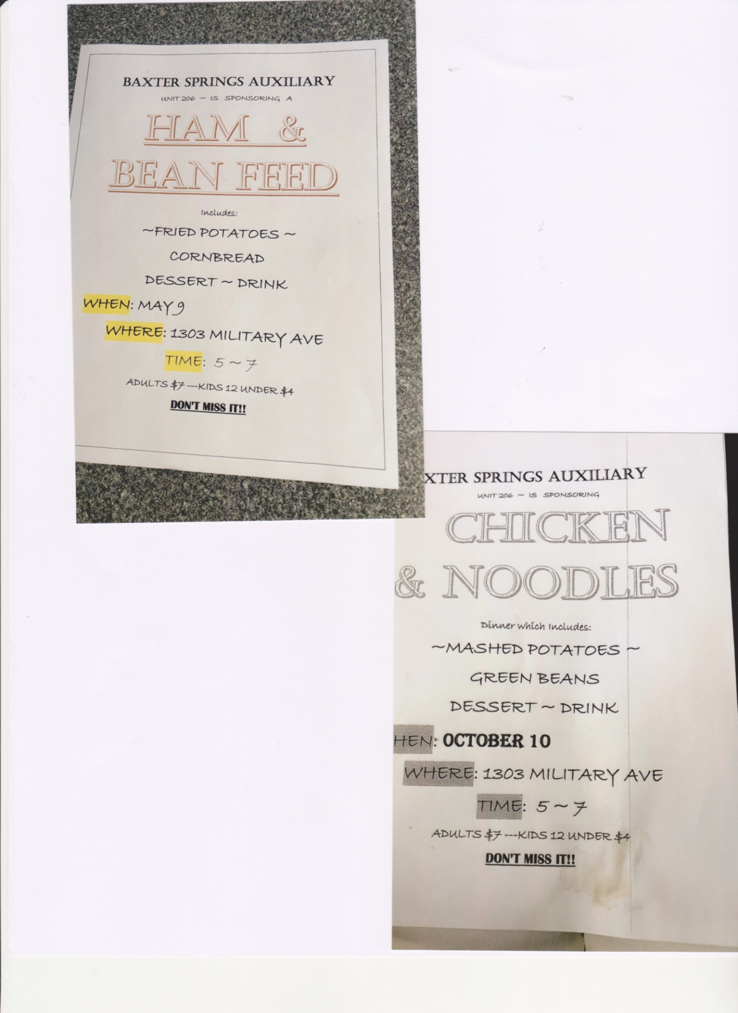“Our unit also hosts 2 community dinners a year to raise money for helping veterans mainly at Christmas, but there are other ways we help them, too.

“We also decorate our frontage in fall to participate in a city wide event.”

Chanute’s Boerstler-May Unit #170 reports having worked 4 hours on the Public Relations program. “1 member of our local unit attended a ribbon cutting for the new Iola VA clinic and took the opportunity to talk about the benefits of the ALA to state and national legislators on site.”

Independence’s Harold R Andrews Unit #139 reports 100 hours worked and spent $250 working the PR program. “American Legion Auxiliary Unit 139 Facebook group page publicizes activities, a calendar of dates and upcoming events to keep member informed. Minutes are published monthly in The *Independence Reporter* & placed in a notebook at the Post. Brea is the editor of our new Unit Newsletter published monthly & available to all members. The resources provided by department and national websites, as well as the *Sunflowerette* provide much needed guidance. Calling Tree CH Cassie follows meeting policy: No School/City Closures – NO Meeting. Promoted ‘Be the One’, TAL & ALA birthdays, & Rosie the Riveter Day, among other military observances. Andrea made new posters to promote the ALA & membership. Attached magnets to 20 patches so members could be in uniform. Purchased and updated ALA Unit Banner & all –weather banner for parades. 5 officers worked as a publicity team for 114 hours spending $250.”

Cherokee’s Priestly-Ridley Unit 35 reports that “We have a Post 35 Facebook page to publicize events and keep members updated. We had 1 member with an article written in *The Pittsburg Sun* about our Legion Post Family wanting to help restore a very old monument at the Pittsburg Atkinson Airport, which is dedicated to Tommy Atkinson, who was known as “the Flying Legionnaire” from Post 64.”

Howard’s Unit #149 Chairman Sarah Evans reports, “We rocked PR this year. We were in the newspaper at least 6 times. We are in the monthly City of Howard newsletter most months. (I write said newsletter, but it still counts.) We have a picnic in August with Girls & Boys Staters and their families. A member of our unit led 2 parades with the Legion members, while our Auxiliary had a float in 2 parades. Our group is a well respected part of our community and we are proud of our reputation.”

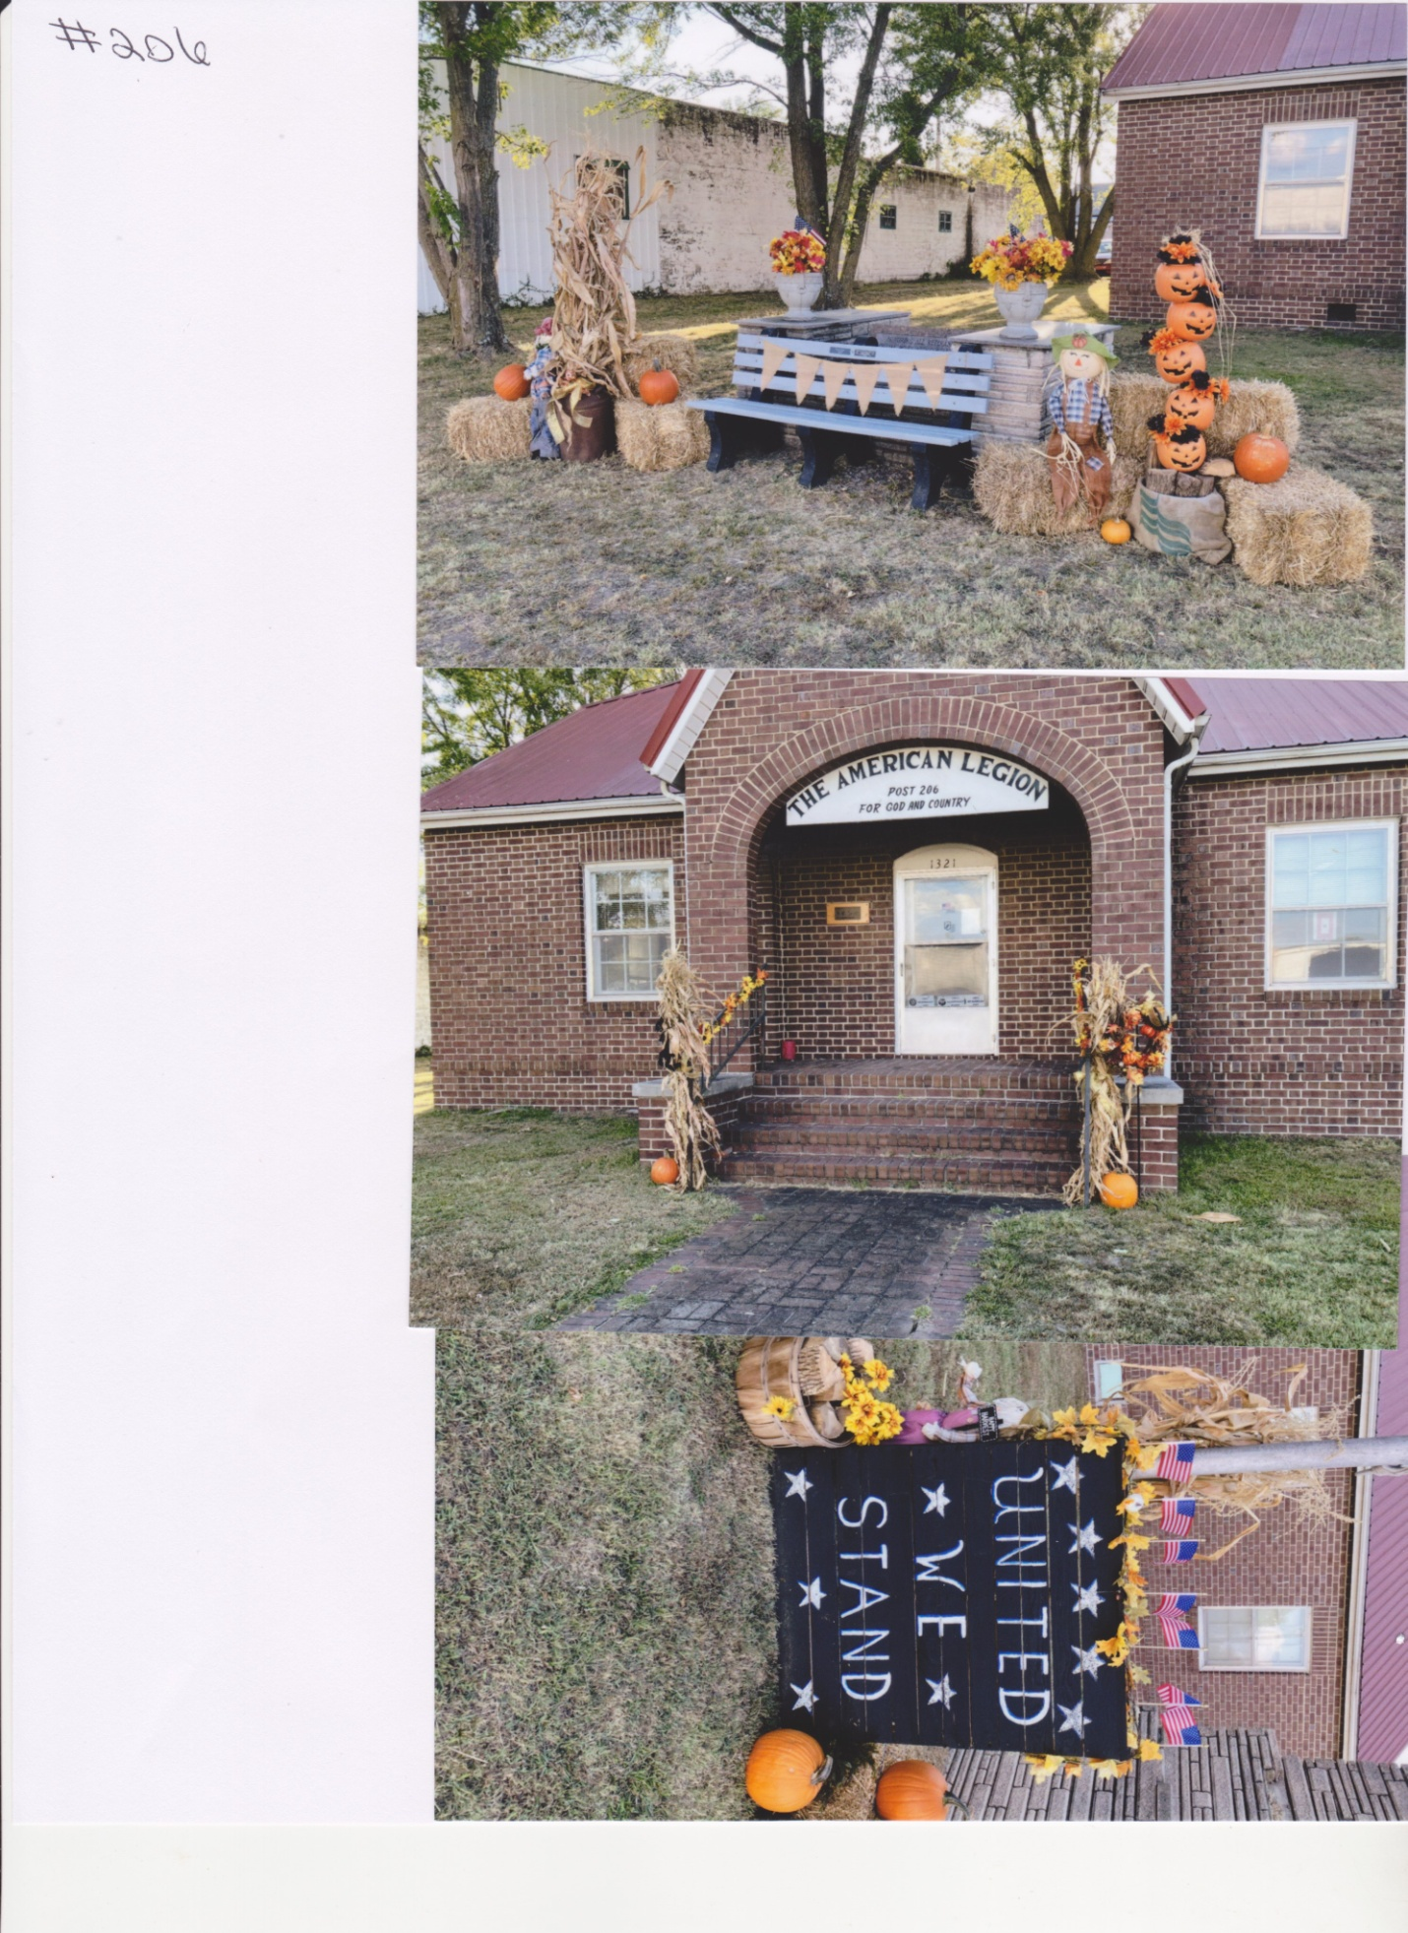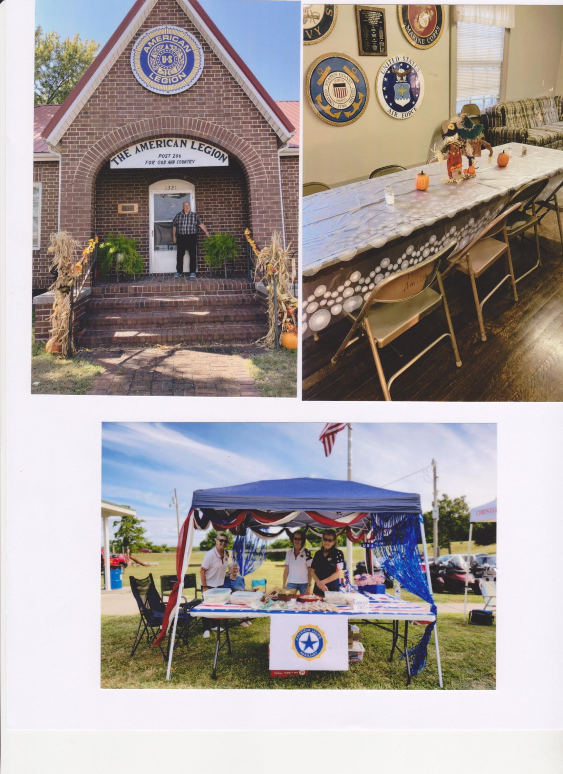

**STRATEGIC PLANNING DOROTHY WAHL**

**THIRD DISTRICT TECHNOLOGY REPORT (Jan – Dec 2024) LA VETA DARBRO, CHAIRMAN**

All sixteen Units (100%) of Third District reported technology is still a scary major obstacle; a work in progress for many Units; aging members, so we back up emails; website information with calls; snail mail to guarantee we are all on the same page.

Volunteers can now track reports & information by utilizing the Department website, an awesome tool. This technology allows us to better meet mission goals, save time & money, attract new donors & volunteers, receive immediate program information, and provide new ways to engage the community.

These report forms helped generate 100% reporting in Third District, however, personal calls still had to be made for reason listed above. ZOOM calls facilitate real-time communication & answers to questions to keep us in the loop. ALAMIS gives us the immediate ability to transmit & account for membership. I didn’t keep track of the number of Units utilizing ALAMIS.

**THIRD DISTRICT VETERANS AFFAIRS & REHABILITATION REPORT (Jan – Dec 2024)**

**LA VETA DARBRO, CHAIRMAN**

All sixteen Units (100%) of Third District reported 4,270 hours worked spending $16,132 traveling 2,160 miles for 872 veterans served. 285 active duty were helped, 230 military kids and 1,431 hours helping military families spending $5,153. Donations reported to Gift Shop = $1,550. School presentations = 5.

**Arma** hosted National Vice Commander Ray Vail with 30 veterans. Members worked 100 hours on a rummage sale – donating $900 to the Post & money to KVH. Members donated $100 meat & sides for the free will Veterans Day dinner/program. $250 donated to Wreaths Across America in Ft Scott. **Arkansas City** buys gifts, donated $300 for postage & helped wrap gifts at KVH. Members took part in the Veterans Day parade, made 12 cakes for the ham & bean feed after. Memorial Day partnered with the Post for 2 cemeteries & one ceremony at the bridge. Helped the Post by donating $2,800 for remodeling & $150 for a refrigerator. The Unit provided meals for 3 veteran funerals.

**Baxter Springs** provides transportation to the Dr for a veteran son & another helps with cleaning & laundry for a veteran brother-in-law. Members help clean the Post following their many events.

**Cedar Vale**’s Cordella Clapp, granddaughter, & great-granddaughter dressed in full Native American regalia at Mid-Winter, 4 Chaplains, Cedar Vale Labor Day, & Ponca City Veterans Day parade signing “The Star Spangled Banner”, “God Bless America” and the “Lord’s Prayer” before a veteran crowd of 300.

**Chanute** made their annual donation of $500 to KVH.

**Cherokee** had seven Auxiliary members of Quilts of Valor present quilts to two veterans. They served Veterans Day dinner to 11 veterans. Six members helped place 300 wreaths for Wreaths Across America in Parsons. 5 members provide transportation to Dr appointments, shop & play games for local veterans. Gifts for 20 veterans purchased at Christmas.

**Coffeyville** had 3 members partner with their SAL to play Bingo at KVH.

**Columbus** assisted 3 veterans with utilities & groceries (1 now deceased).

**Erie** helped their Post with the annual Bean Feed concession stand & Rodeo benefitting their veterans & programs. They help place flags on graves on Memorial Day at 3 cemeteries. Donated $200 for postage to KVH.

**Howard** donated $1,155 and $500 worth of items to KVH.

**Independence** donated $50 to Gift Shop. $100 to Veterans Freedom Square Memorial in Independence Riverside Park & Avenue of Flags. $105 to AWOL Pets4Vets (program that provides pets to veterans free) & packed adoption kit bags of supplies. Took 80 Valentines for Veterans to KVH and another 40 for Post members & homebound. President’s veteran family donated $3,000 value durable medical supplies & new clothing to KVH following his death. The Unit donated $100 to Post #139 March 15 for their Birthday. Six Auxiliary member/ALR took part in Run for the Wall in May. ALA Foundation Cards in support of National President Trish Ward & the Veteran Project Fund were donated to the Unit. Members provided Buddy checks, personal care, transportation, shopping, laundry & assistance to veterans all year long.

**Winfield** purchased 10 wreaths @ $17 each with 11 members helping for Wreaths Across America at KVH. KVH keeps volunteers busy year round. Bingo 1st, 3rd, 5th Mondays and Cheer Cart 2nd & 4th Mondays, as well as, providing the bulk of manpower for Gift Shop set up, shopping, take down, delivery & mailing. The Unit also donated $500 to KVH & put up poppy door decorations. 2 members send cards/gifts to female veterans. Donations to Passageways provide for homeless veterans. Members love to help with fundraising with bake sales & paint parties.

***American Legion Auxiliary***

**DISTRICT/COUNTY/COUNCIL**

**Year-End Impact Numbers Report**

**District/County District 3 Department Kansas**

**Number Units in District/County 16 Number of Units Reporting __7**

**Total Number of Members Reporting 460**

**Your name Debra Carr______ Email debrajcarr@gmail.com _______**

1. **Our ALA Service for Veterans/Active-Duty/Reserve Military**

|  |  |  |  |
| --- | --- | --- | --- |
|  | **Service for Veterans/Military** | **Obtain**  **Total From** | **Total** |
| Line 1 | Total hours members volunteered | *Unit Form Line 1* | 4637 |
| Line 2 | Total dollars spent | *Unit Form Line 2* | $10198 |
| Line 3 | Total number of veterans/military assisted | *Unit Form Line 3* | 2840 |
| Line 4 | Total number of “*Veterans in Community Schools”* presentations facilitated | *Unit Form Line 4* | 5 |
| Line 5 | Value of in-kind donations received* | *Unit Form Line 5* | $120 |
| Line 6 | Total number of poppies or poppy items distributed | *Unit Form Line 6* | 1290 |
| Line 7 | Total dollars raised from poppies | *Unit Form Line 7* | $ 650.61 |

*Estimated cash value of non-cash donations from **NON-MEMBERS** of goods (like paper goods, clothing) or services (like pro-bono CPA services from a local firm)

1. **Our ALA Service for Military Families**

|  |  |  |  |
| --- | --- | --- | --- |
|  | **Service for Military Families** | **Obtain**  **Total From** | **Total** |
| Line 8 | Total hours members volunteered | *Unit Form Line 8* | 1271 |
| Line 9 | Total dollars spent | *Unit Form Line 9* | $3985 |
| Line 10 | Total number of military families served | *Unit Form Line 10* | 242 |

1. **Our ALA Service for Youth**

|  |  |  |  |
| --- | --- | --- | --- |
|  | **Service for Children & Youth** | **Obtain**  **Total From** | **Total** |
| Line 11 | Total hours for ALA Girls State | *Unit Form Line 11* | 30 |
| Line 12 | Total dollars spent for ALA Girls State | *Unit Form Line 12* | $1100 |
| Line 13 | Total hours for other Legion Family youth activities | *Unit Form Line 13* | 583 |
| Line 14 | Total dollars spent on goods for youth activities | *Unit Form Line 14* | $200 |
| Line 15 | Total dollar amount of direct aid to help  a needy child | *Unit Form Line 15* | $1005 |
| Line 16 | Total other **UNIT** expenses (parties, dinners, paper goods, trophies) | *Unit Form Line 16* | $400 |
| Line 17 | Total number of children/youth served | *Unit Form Line 17* | 4129 |
| Line 18 | Total dollars to other child service charities | *Unit Form Line 18* | $668 |

1. **Our Service Representing the ALA in Our Communities**

|  |  |  |  |
| --- | --- | --- | --- |
|  | **For any service not included in Sections 1-3** | **Obtain**  **Total From** | **Total** |
| Line 19 | Total number of hours | *Unit Form Line 19* | 3500 |
| Line 20 | Total dollars spent | *Unit Form Line 20* | $ 4356 |

1. **Scholarships our Units & District/County Presented/Awarded**

|  |  |  |  |  |  |
| --- | --- | --- | --- | --- | --- |
|  | **Scholarships** | **Obtain**  **Total From** | **Units** | **District or County** | **Total** |
| Line 21 | Total number of scholarships presented  or awarded | *Unit Form Line 21* | 6 | 0 | 6 |
| Line 22 | Total dollar amount of scholarships | *Unit Form Line 22* | $2355 | $0 | 2355 |
| Line 23 | Total dollar amount donated to department scholarships | *Unit Form Line 23* | $250 | $0 | $250 |

***When completed, send to****: by*

*(Get name and date from district or county, if applicable, or department)*

**CONGRATULATIONS---YOU DID IT! THANK YOU FOR ALL YOU DO**

**AND FOR REPORTING YOUR DISTRICT/COUNTY/COUNCIL’S IMPACT!**